Group Project – Flint Water Line Replacements 2016

DS633 - Data Mining for Business Applications

Winter 2020

Jasmine Li

Rabia Otry

Edna Pinzon

Anqi Zhang

____________________________________________________________________________

**Background:** In Flint’s water crisis problem, we are given 340 records from 2016 to create a predictive model to determine whether the water is dangerous. We used JMP and Tableau software to determine a model, create a prediction analysis, and visualize the model and demographics.

Part 1 Visualizations and their story

1. Demographics

According to the American Community Survey by census block (1 to 6), the black population is the most concentrated in census block two and the white population is the most concentrated in census block 6. The average aggregate income and land value of census block 6 is the highest among all census blocks. Census block 5 has the highest fraction of dangerous service lines, with 100% service lines made of lead or being galvanized. Whereas 0% of service lines in census block 6 are dangerous.

Census block is not necessarily divided by geographic locations. Census blocks 1-4 are quite dispersed. Census block 5, however, is the closest to the Flint River, and census 6 is further from the river.

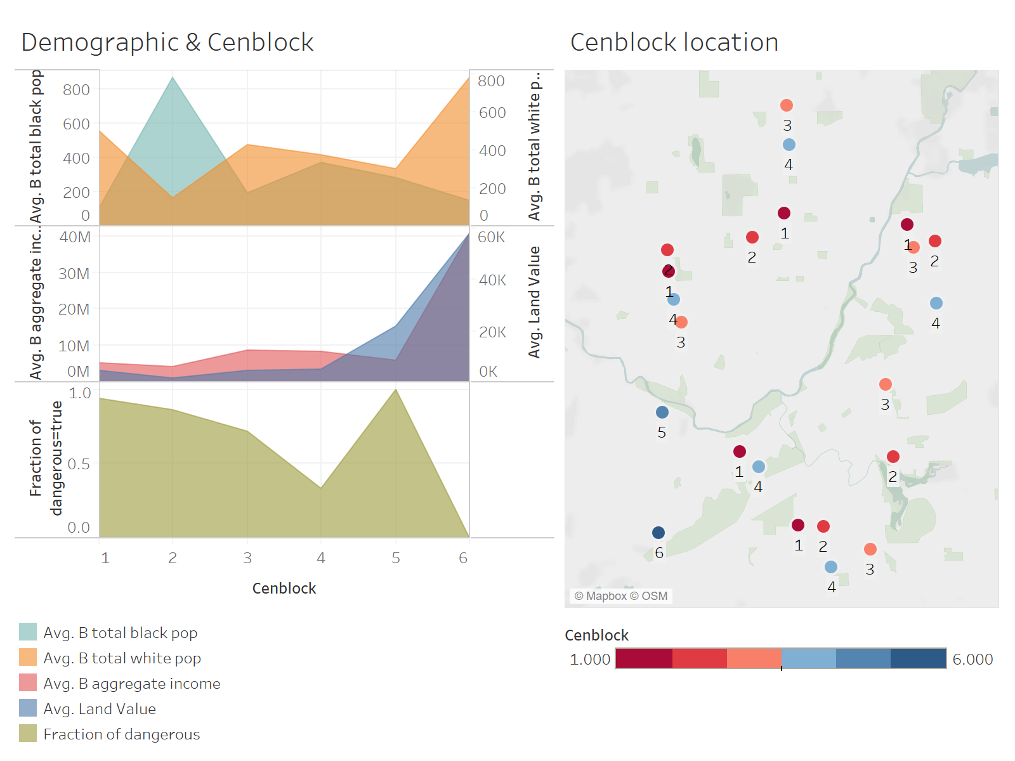

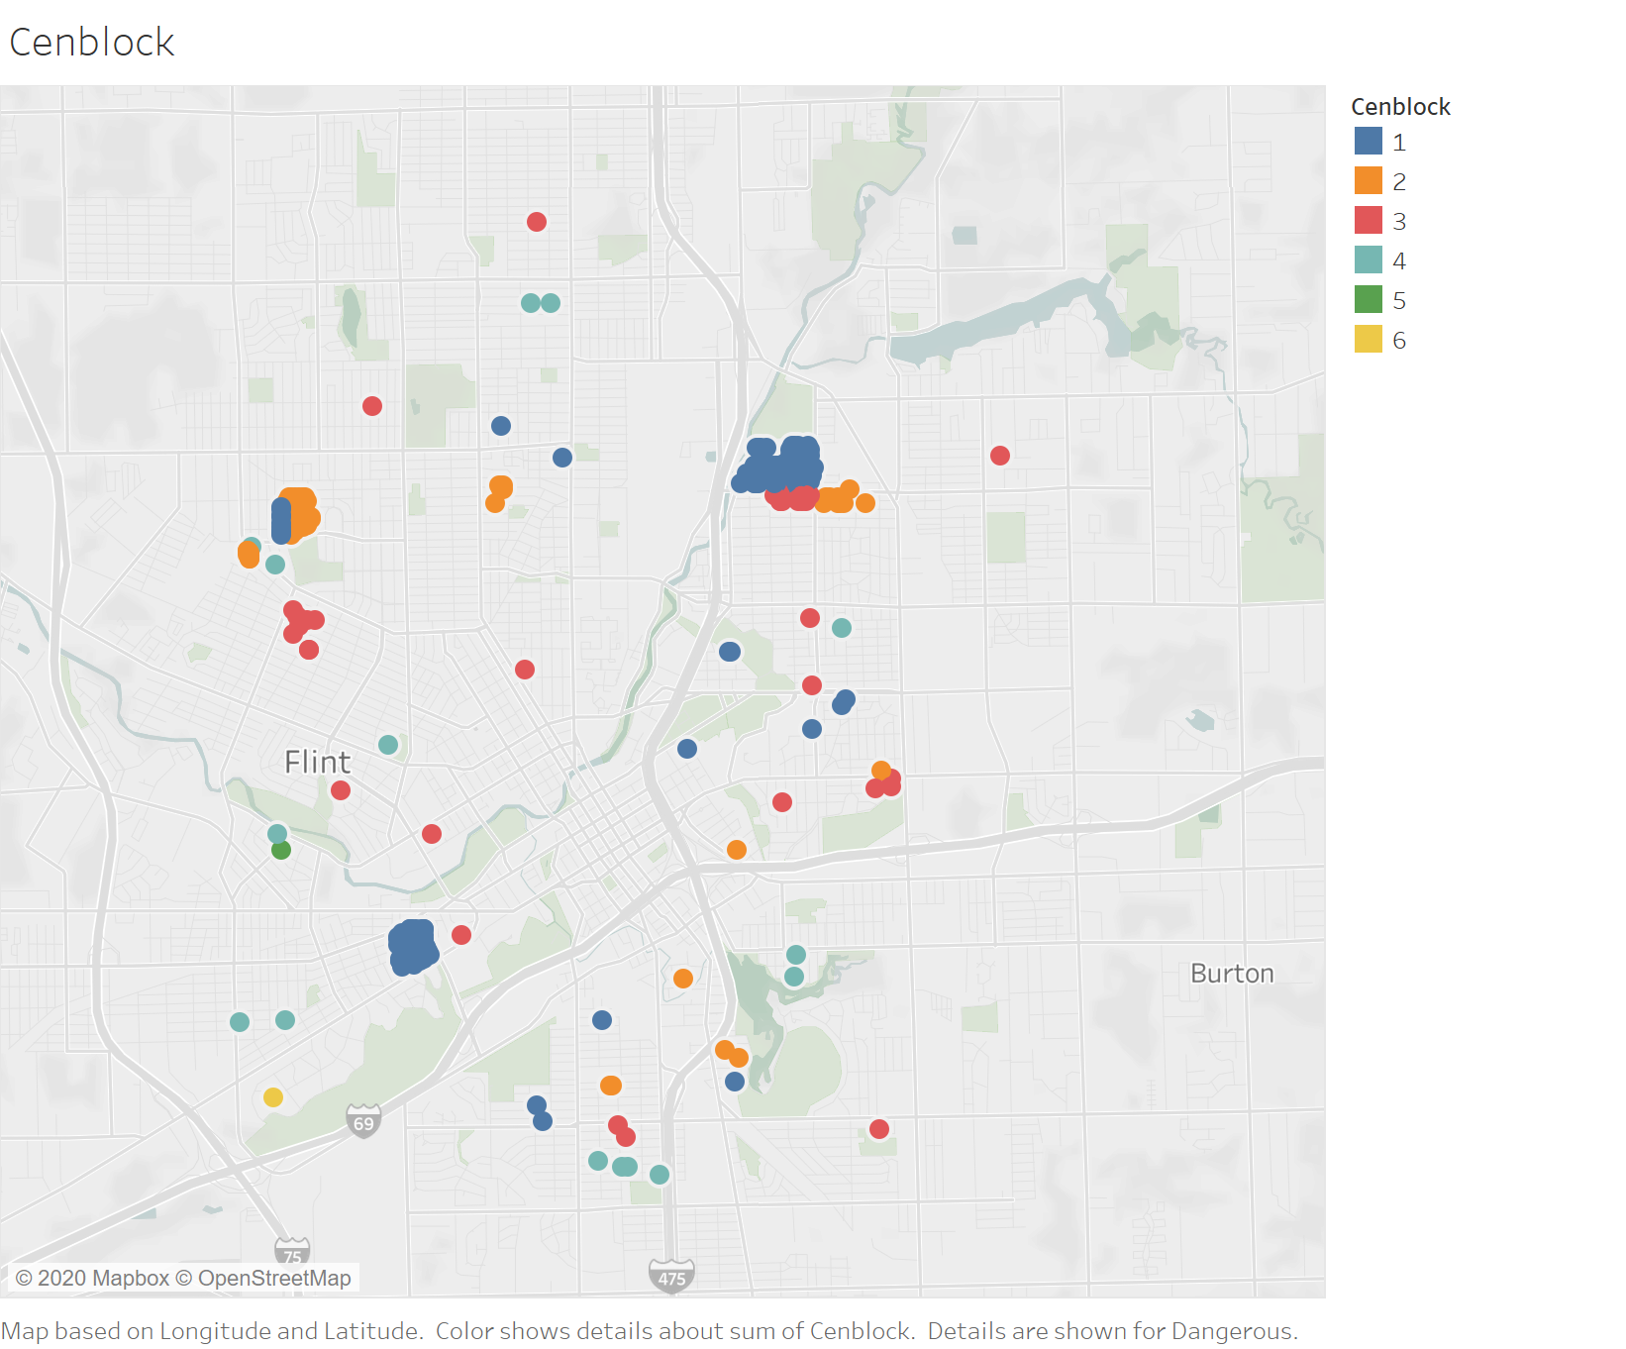

Cenblock 1 has the majority of dangerous instances, comprising nearly 60% of all dangerous cases across all cenblocks.

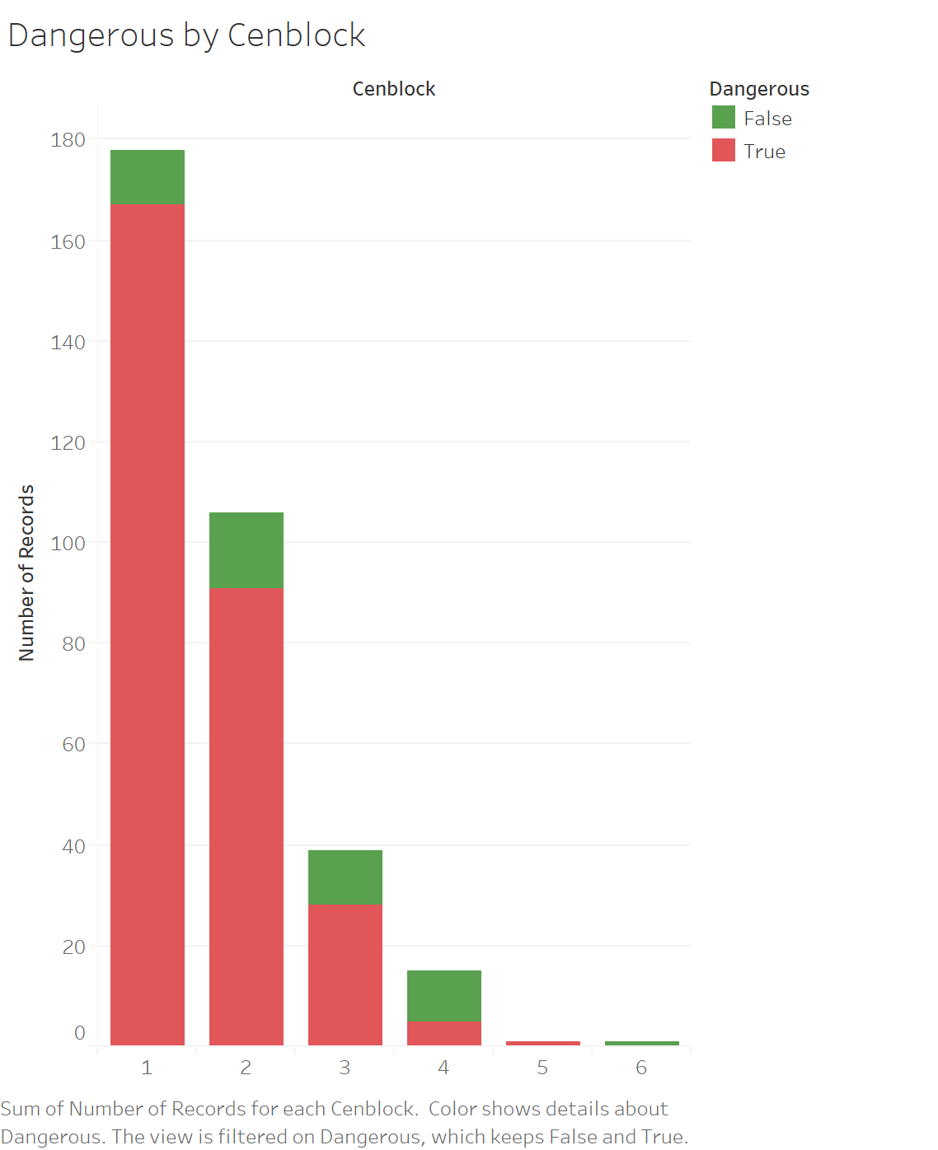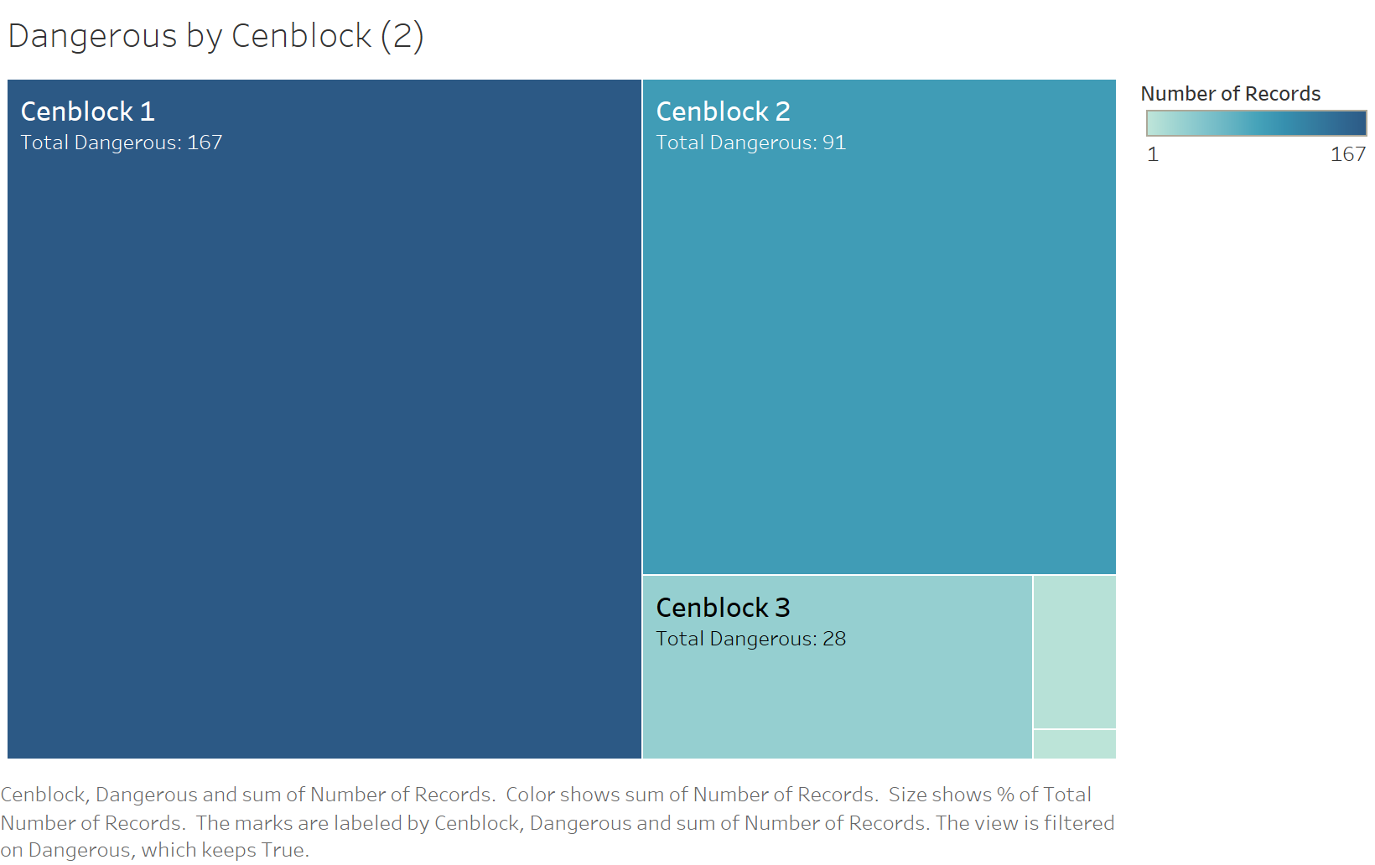

2. Age of property

There are two surges of building properties: after around World War One and World War Two. The service lines contained dangerous materials in most years.

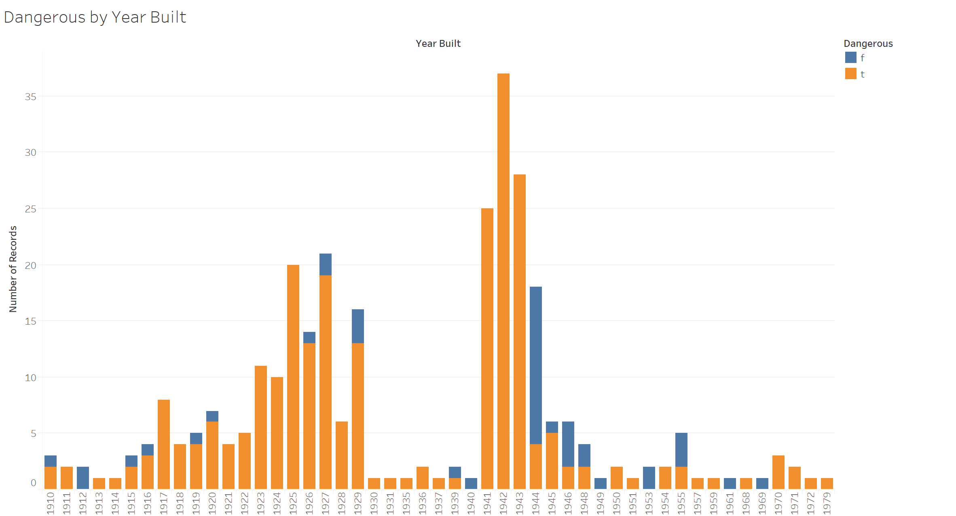

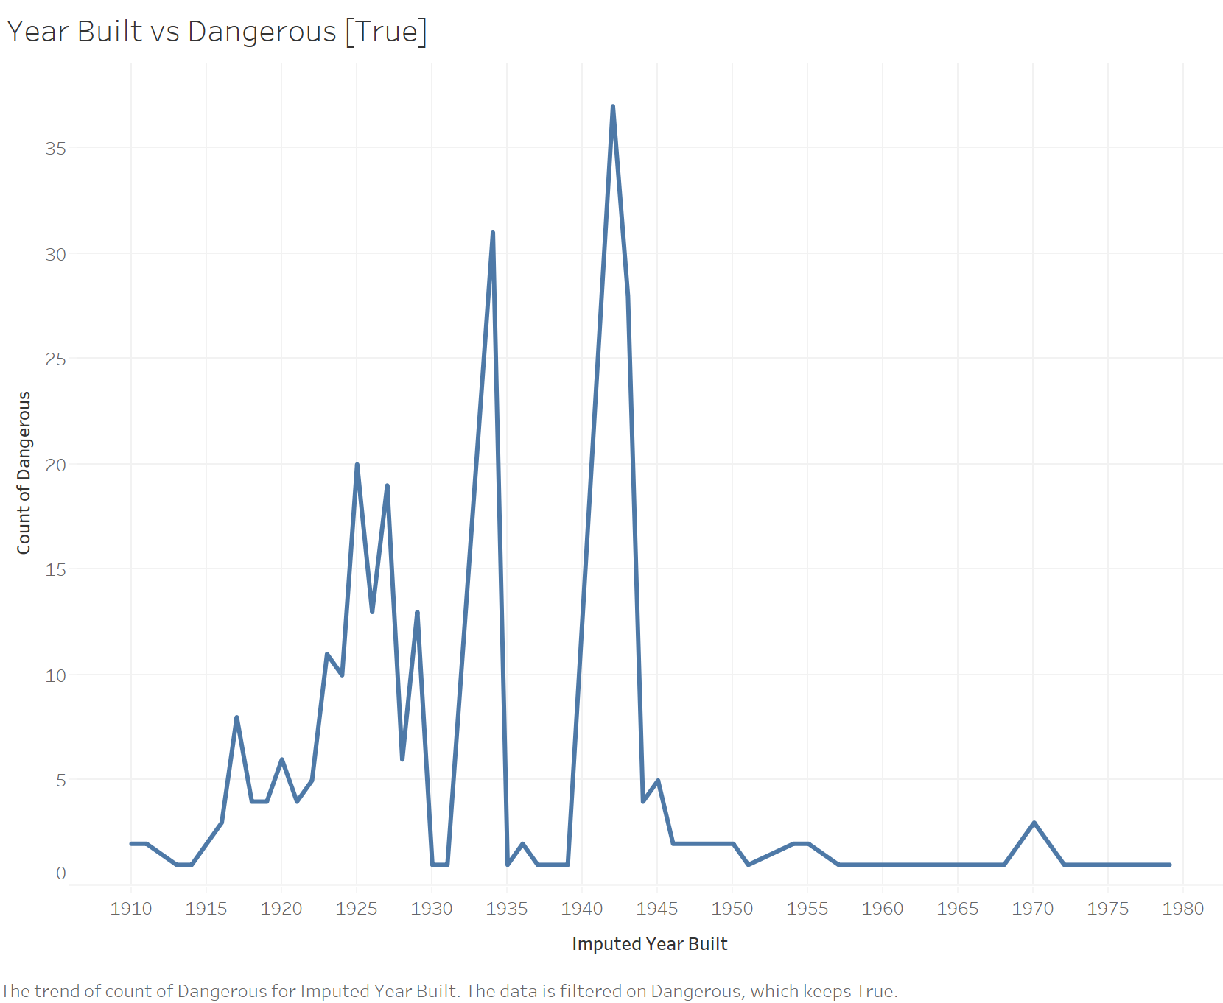

3. Service line inspection

The map on the left shows the result of the inspection of private service lines conducted by Michigan Dept of Env. Quality. The result is NOT consistent with the map on the right, where the orange dots means there are lead or galvanized in either the private service line or the public service line of the property.

Some orange dots on the right map shows “unharmful” on the left map, which can be explained that there might be dangerous material in the public service line. However, the properties which are marked “Lead” or “Galvanized” on the left map and meanwhile blue on the right map can be really problematic.

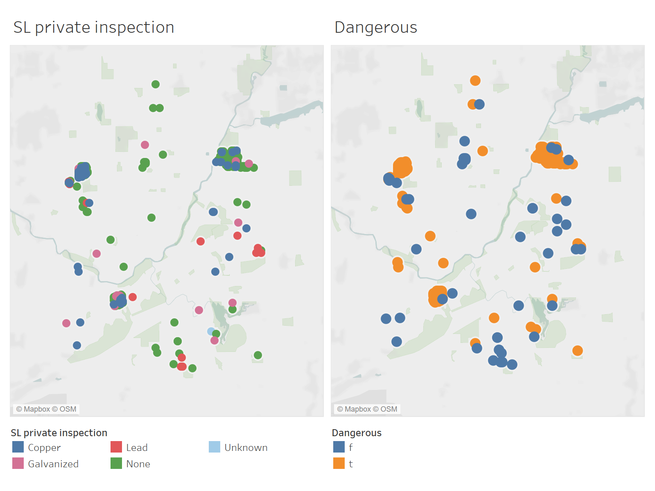

Part 2: Details on modeling challenges and choices

After doing a distribution analysis and reviewing each variable, keeping in mind that we want to build a model as simple and reliable as possible, we found that the challenges in the modeling include:

**1.** There are many variables included, and some of them are either out of date (e.g., Old Prop Class), not reliable sources: there are different data sources, e.g., B_Series demographic variables, which are from surveys, and maybe suspect. Therefore, we decide not to include B-Series in the model selection.

**2**. The data are not from the same time period. E.g.: USPS is updated 2016, while there are housing conditions 2012, and 2014, and commercial condition from 2013.

**3**. There are Unknown or None in the data: e.g. Last_Test has “None”, SL_private_inspection has “None”.

**4**. Some vacant or outliers in the data: Homestead = 0, HomeSEV = 0

**5**. Missing data: Year_Build has value = 0 and 2, which does not make sense, may be treated as a missing value. Year_Build column has 204 missing values. And there are other columns with missing values. We decided to use informative missing for those other columns. We specially treated Year_Build, since it could be one of the significant factors in model selection. We code Year_Build =0 and 2 as Missing. Then use Explore Missing Value in JMP, thus creating an Imputed Year_Build which missing data is automatically imputed.

**6**. It is not clear which variables are useful, which are not. For example, we do not know how will Owner State, Draft Zone, and Zoning affect the dangerous level of the service line, and the content in these variables are strings or characters which would not be recognized in the model, so they are not considered as effective variables. Also, Use Type and Prop Class have similar values. We need to decide to use both or drop one of them.

**7**. There are variable values that cannot be interpreted: For example: B_median_age_all_women_white has value = -1, so does Max_Lead and Med_Lead. We do not know what that means.

Data preparation choices:

After reviewing the Dictionary of variables, we exclude some variables that do not make sense to be included in the model. The B-series have predicted values for each census block by the American Community Survey. These should be considered suspect. So we exclude these columns first. Later in the model-building stage, we dynamically include or exclude some variables based on the performance of the model.

Make a validation column, using 70% for the training set and 30% for the validation set, set random seed = 633.

Deal with missing values in Year_Build: Code row value = 0 and 2 as a missing value. In JMP, Make an Imputed_Year Built column on menu Analyze-> Screening -> Explore Missing Value. Furthermore, we also try to bin it as a categorical variable: Bin Imputed_Year_Build with bin size = 20.

Next, we do a multivariate check to see if there are any correlations between the variables. The multivariate table is in Appendix 1.

There are some correlated variables. For example, the variables below are highly correlated with each other (with correlation > Absolute value of 0.6). Then we try to exclude one in each pair for now for further data analyzing.

HomeSEV - Land Value –Parcel Acres (remove Land Value)

Land Improvement Value – Parcel Acres (remove Parcel Acres)

Residential Building Value – Longitude (remove Residential Building Value)

Latitude – Ward (remove Ward)

Centract – Precinct (remove Centract)

Do a Multivariate check again, there are still some correlated variables.

Latitude – Precinct (remove Latitude)

Longitude – Zip Code (remove Longitude)

SL_Type2 – Land Improvement Value (remove SL_Type2)

Finally, recode SL_Private_Inspection: Copper = 0, the rest = 1. Since Copper means it is safe, the others we do not know, for the purpose of conservativeness, we code them as 1, which means not safe

Part 3: Prediction methodology/approach

We tried out many prediction models. We evaluate their performance by choosing the one with the highest ROC (Receiver operating characteristic) and Area under the Curve (AUC) scores. When using JMP to model, we always check for “Informative Missing” checked. Here is the process of the model selection.

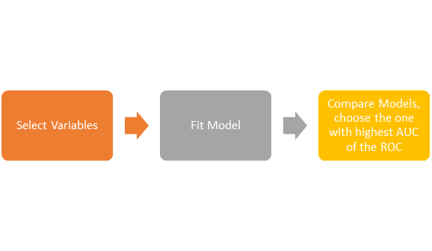

Fit Logistic Regression

Select the variables shown in Appendix 2, and fit a Logistic model, with Informative Missing function in JMP. This will automatically evaluate the missing values in the variables and output a sound result.

Here are the significant variables in the output we got from the Logistic Regression Model:

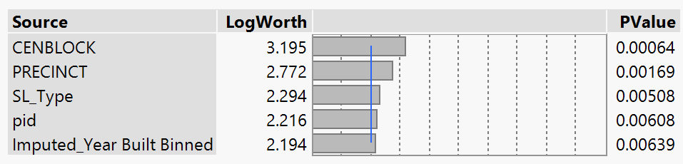

It seems that CenBlock, Precinct, SL_Type, pid and Year_Built are significant factors in determining dangerous service line, with CENBLOCK contributed the most. We got an ROC = 0.8429, see appendix 3. The variables are all significant, stable, and unbiased. We also tried Stepwise. There are some reasons we did not select Stepwise. First, it automatically separates polynomial categorical variables, makes it difficult to delete insignificant variables. Second, the result we got from Stepwise is very close to a normal Logistic model.

Fit a Classification and Regression Tree Model

In JMP, we use Partition, a Partition with continuous Imputed_Year_Build, we got ROC = 0.8967, see Appendix 4 for variable selection.

Fit Bootstrap Forest

We did a Bootstrap with continuous Imputed_Year_Build, we got ROC = 0.9261, using default specifications. See Appendix 5 for Default Specification for Bootstrap Forest. In this case, we also tried Bootstrapping with Imputed_Year_Build Binned, using default specifications, got a ROC = 0.9304. We also tried Bootstrapping with Imputed_Year_Build Binned, using Number of Trees in the Forest = 500, specifications, ROC = 0.9641. See Appendix 6 for Bootstrap Specification with Number of Trees = 500.

We also tried Bootstrap with Imputed_Year_Build Binned, using Number of Trees in the Forest = 1000, specifications, ROC is no better than above.

Fit Boosted Tree Model

Fit Boosted Tree with continuous Imputed_Year_Build, number of layers = 100, ROC is close to Bootstrap method. We tried other boosted trees with different specification inputs, the results are no better than above.

Fit Neural Network Model

We tried the Neural Net model in JMP, using Imputed_Year_Build Binned, both layer 1 and layer 2 set function = TanH, node = 3, we got ROC = 0.8359. We also tried using Imputed_Year_Build Binned, layer 1 function = TanH, node = 3; layer 2 function = Linear, node = 3, we got ROC = 0.8891

Part 4 - Performance evaluation results

Here is a summary of all the models we tried. Using AUC of ROC, as shown below. Please be noted that since we did not set up random seed for the models we discussed above, so every time, with the model running randomly, we could get slightly different AUC and ROC. However, we still choose Bootstrap as the selected model. See model comparison and AUC in Appendix 7. Thus, we choose Bootstrapping using Imputed_Year_Build Binned, Number of Trees in the Forest = 500 in specification as the best choice, with ROC = 0.9641.

Visualization of our model’s predictions of actual Dangerous [True]. As you can see, our model classified almost all Trues as True.

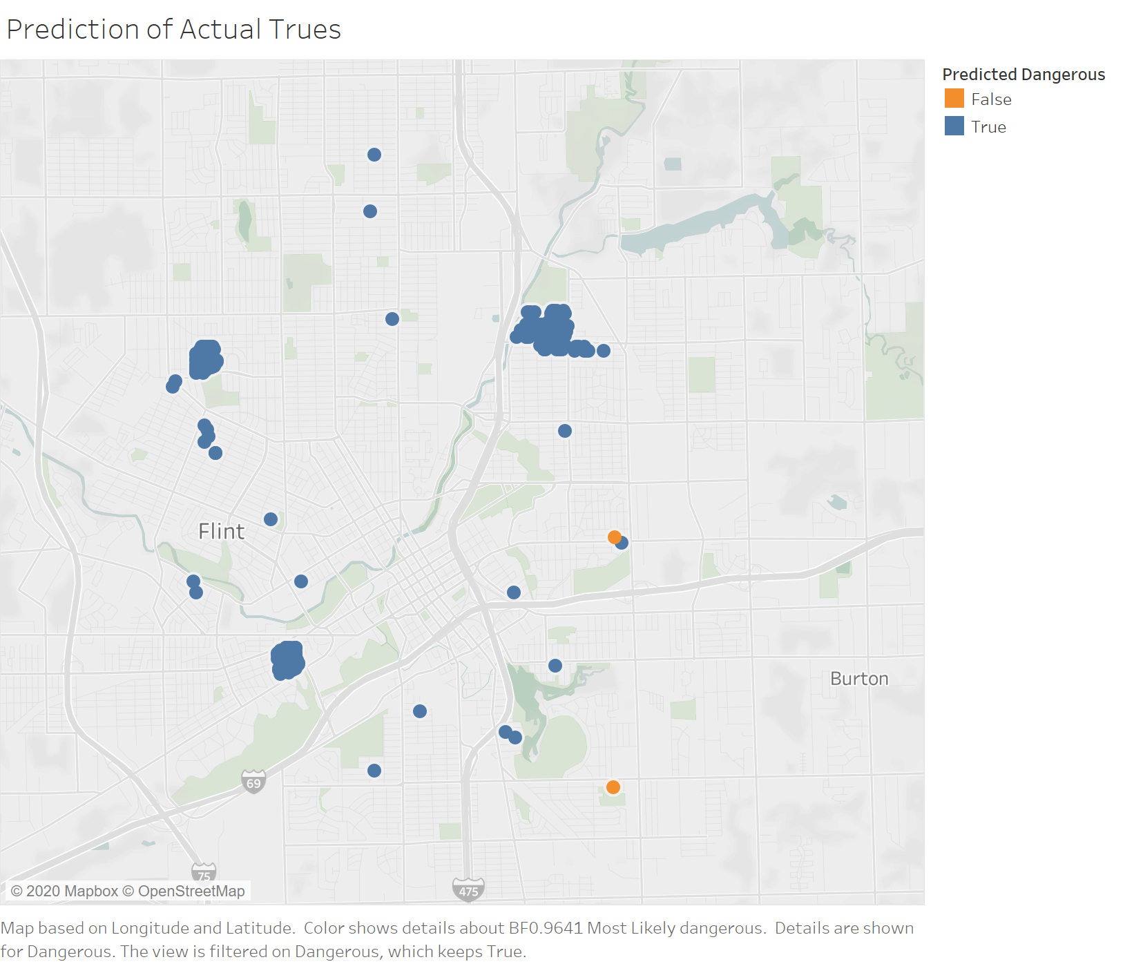

This is also supported by our prediction model’s confusion matrix. Thus, our model predicts nearly all the accurate trues successfully, with the human health cost of misclassification of actual Trues being much higher than that of Falses.

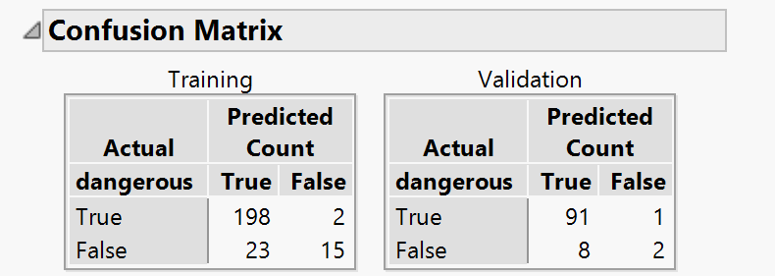

Part 5 - Prediction on new test data

We use the best choice mentioned above to predict new data. Using the three-row mini test set, we think these three parcels are all dangerous, which service lines need to be replaced. See Appendix 8 for the prediction result.

Appendix

Instructions for running the analysis

In the associated JMP file, all the columns are saved in the original order in order to be able to run each script that has been saved, which is shown in the upper left screen in JMP.

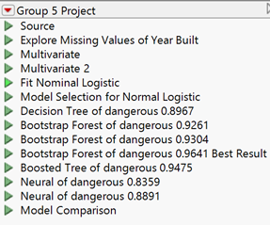

The order of the scripts is the same as the order of the models mentioned above. The models saved are also annotated with the according ROC.

Model comparison is a summary of the models being tried. In the lower left screen, shows the columns. The calculated columns are shown below:

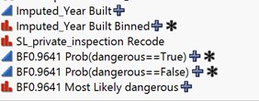

The prediction formulas are saved as BF0.9641, stands for Bootstrap Forest, which is the model being selected.

1. Multivariate Table

**Correlations** 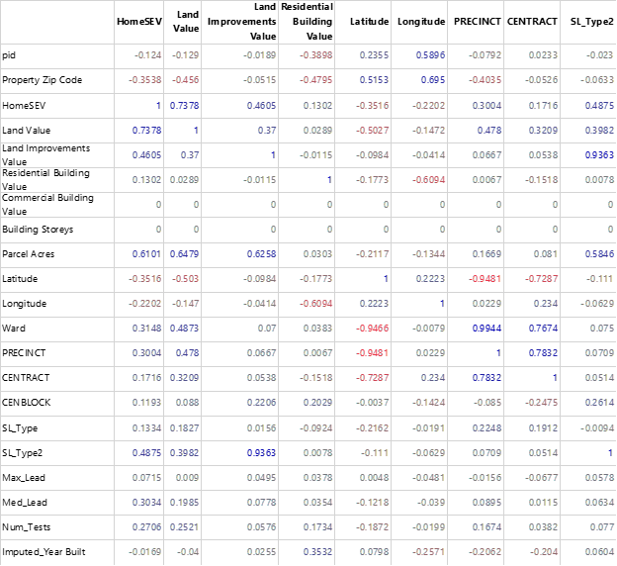

The correlations are estimated by Row-wise method.

2. Logistics Regression Model Specification

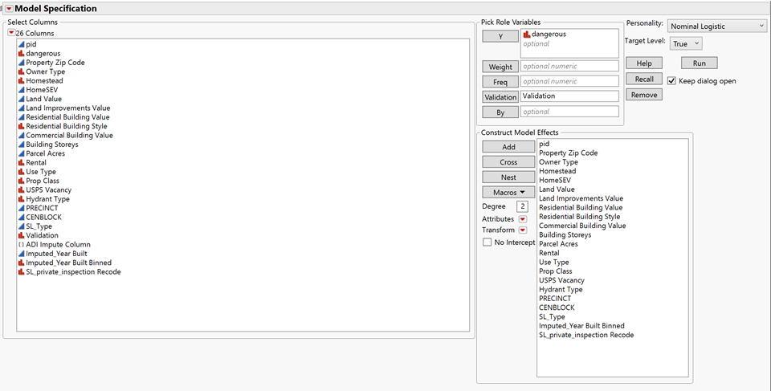

3. ROC of Logistic Regression

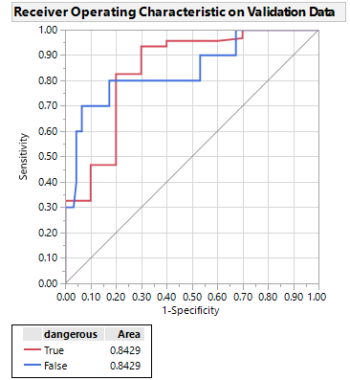

4. Variable Selection for CART (Partition) 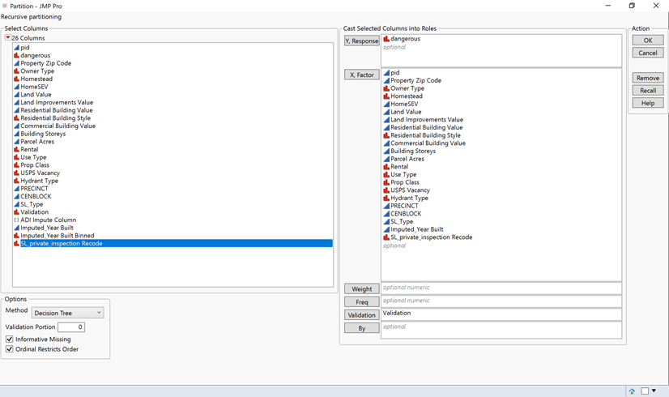

5. Default Specification for Bootstrap Forest

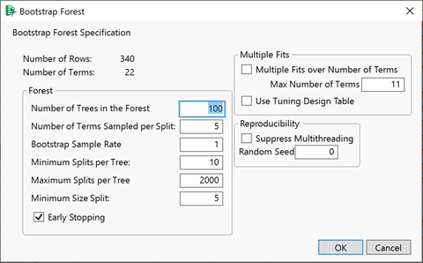

6. Bootstrap Specification with Number of Trees = 500.

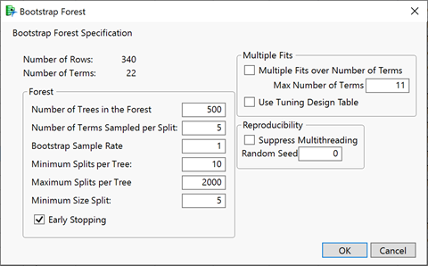

7. Model Comparison

Using a local data filter of Validation=Validation, we can see that the third Bootstrap Forest model with an AUC of 0.9641 has the highest AUC and is therefore selected as the best model. Additionally, it has one of the lowest RMSE.

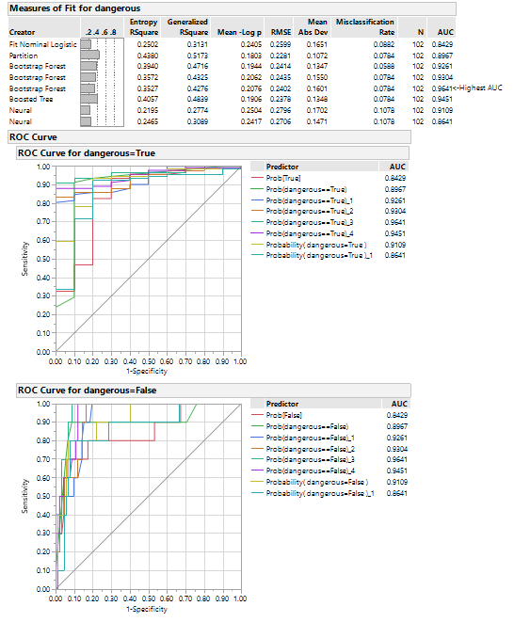

8. New Data Prediction

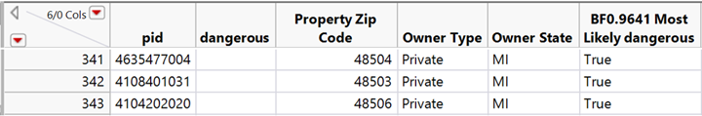

9. Additional Visualizations

*Income*

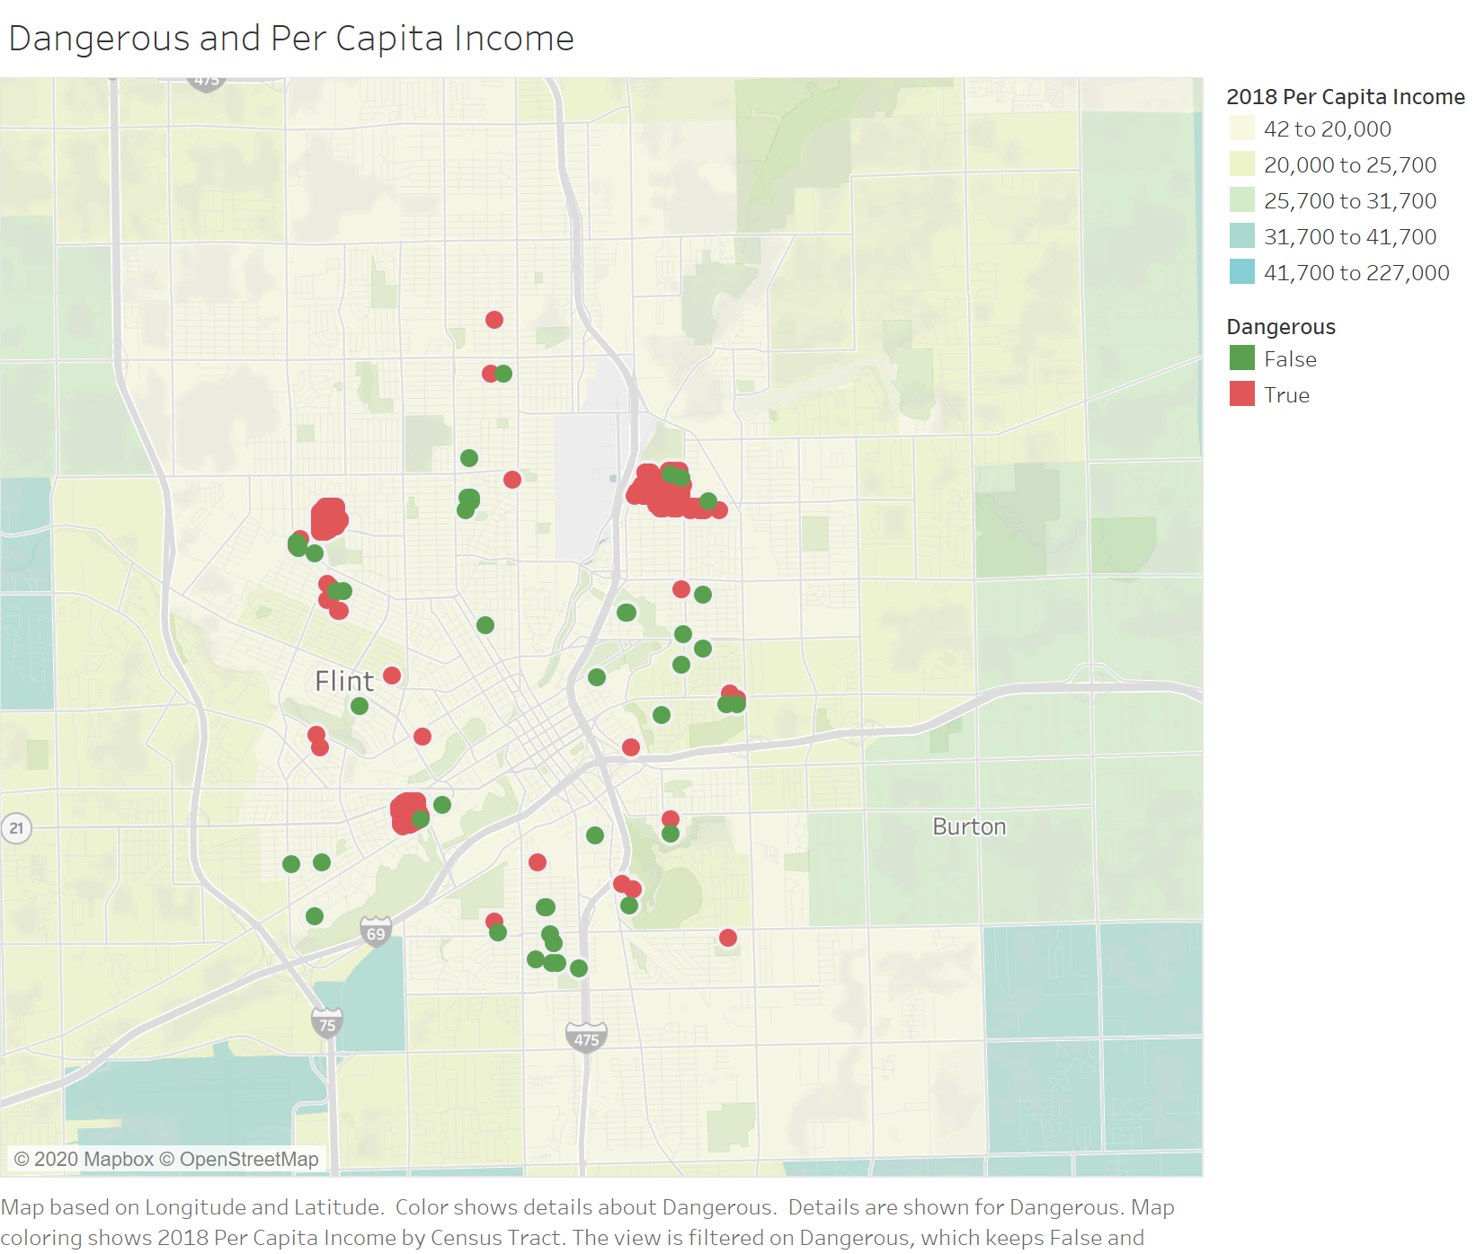

*Population*